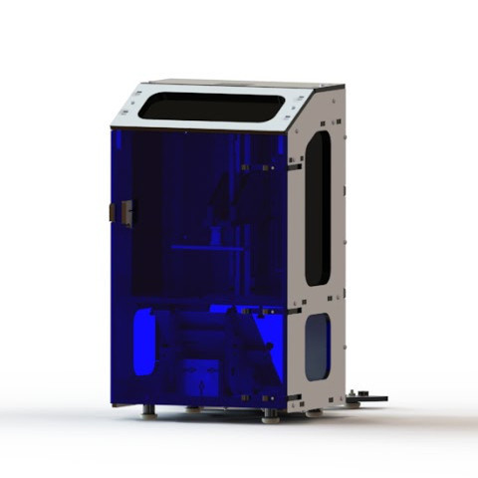


DropLit® v2 Resin 3D Printer User Guide
First Edition
v1.00 – June 29th, 2016
For nanoDLP
Copyright 2016 By Gene Buckle – geneb@deltasoft.com
Licensed as Creative Commons, Attribution-ShareAlike 3.0
Disclaimer text provided by LulzBot.
Official support is available through support@seemecnc.com
As a new SeeMeCNC printer owner, you’ll also find a ton of great resources on the forums at forum.seemecnc.com

READ ME FIRST!

READ THIS MANUAL COMPLETELY BEFORE UNPACKING AND POWERING UP YOUR
PRINTER!

Hazards and Warnings

The SeeMeCNC Eris® Delta 3D printer has motorized and heated parts. When the printer is in

operation always be aware of possible hazards.

Electric Shock Hazard

Never open the electronics bay of the printer while the printer is powered on. Before removing

the access door, always power down the printer and unplug the AC line cord.

Fire Hazard

Never place flammable materials or liquids on or near the printer when powered on or in

operation. Liquid acetone and vapors are extremely flammable.

Pinch Hazard

When the printer is in operation, take care to never put your fingers in the moving parts,

including the belts, pulleys or gears. Also, tie back long hair or clothing that can get caught in

the moving parts of the printer.

Static Charge

Make sure to ground yourself before touching the printer, especially the electronics.

Electrostatic charges can damage electronic components. To ground yourself, touch a

grounded source.

Age Warning

For users under the age of 18, adult supervision is recommended. Beware of choking hazards

around small children.

Table of Contents
1 – Downloading Software 3
2 – Installing the Mini-Rambo Firmware 6
3 – Installing nanoDLP 10
4 – Configuring nanoDLP 12

1 – Downloading Software
Your new DropLit v2 3D printer utilizes two controllers. First is the Mini-Rambo controller. This device is what actually controls the stepper motor that moves the build platform out of the resin vat as the print progresses. It uses the SeeMeCNC version of Repetier Firmware.
The second controller is a Raspberry Pi 3. This device is what runs the nanoDLP software and in turn talks to the Mini-Rambo controller.
In order to start printing, you're going to need to install Repetier Firmware on to the Mini-Rambo and nanoDLP on to the Raspberry Pi 3.
You'll be downloading four packages and an ssh terminal program. The Mini-Rambo firmware, Arduino IDE, nanoDLP, a tool for writing SD card images, and a secure shell program for accessing the Raspberry Pi 3 directly.
The first download is for the Mini-Rambo controller. You'll want to go to SeeMeCNC's github repository and download the Mini-Rambo firmware – see https://github.com/seemecnc/Firmware. Click the Clone or download link and then on the Download ZIP button as shown below.
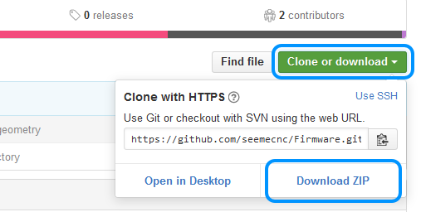Downloading the Mini-Rambo firmware.

In order to compile the firmware and upload it to the Mini-Rambo, you'll need to head over to the Arduino website here: https://www.arduino.cc/en/Main/Software and download the installer for your platform. Keep in mind that this manual will only cover the Windows & MacOS installation procedures – the Linux process should be similar to that of MacOS.

Next, you'll need to download nanoDLP itself. The nanoDLP download comes as an SD card image file that contains the operating system for the Raspberry Pi 3 as well as the nanoDLP software itself. Here's the nanoDLP download link: http://www.nanodlp.com/nanodlp.zip. If that download link doesn't work, just hit the main nanoDLP website at http://www.nanodlp.com and search for the Download link.
Now you'll need to download software that will allow you to write the nanoDLP SD card image to an SD card. For Windows users, you'll download a utility called Win32DiskImager and install it. Win32DiskImager can be downloaded from SourceForge: https://sourceforge.net/projects/win32diskimager/
Click the green download link as shown below.
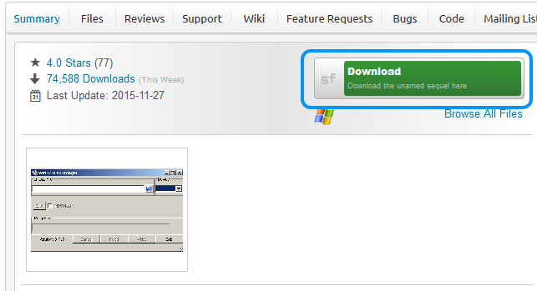Win32DiskImager download link.

The SD card writing process for MacOS is more complex. Fortunately, the wonderful folks at the Rasberry Pi foundation have created an excellent tutorial for this process. You can find detailed instructions at the website link below. (I'll show that link again after you're done loading the Mini-Rambo with the softare IT needs.)
https://www.raspberrypi.org/documentation/installation/installing-images/mac.md
The last program you need is a secure shell terminal program. This is needed to talk directly to the Raspberry Pi 3 instead of using the nanoDLP web interface. If you've already got an ssh program, great! If not, I highly recommend PuTTY. It can be downloaded here:
http://www.chiark.greenend.org.uk/~sgtatham/putty/download.html
There is no installer – it's a single stand-alone executable called putty.exe. I'll cover how to use PuTTY later.

Unzip the firmware and nanoDLP files into their own directories and install the Arduino IDE and (in the case of Windows) the Win32DiskImager packages. Note that Win32DiskImager may ask to be run after the installer finishes. Untick the box for that and click OK. Win32DiskImager has to be run with administrative privileges in order to write out the SD card image. I'll cover that in a bit.
Next, we'll cover configuring the Arduino IDE and uploading firmware to the Mini-Rambo!

2 – Installing the Mini-Rambo Firmware
Start the Arduino IDE and then click on Tools and then Board. Select “Arduino/Genuino Mega or Mega 2560” as shown below.
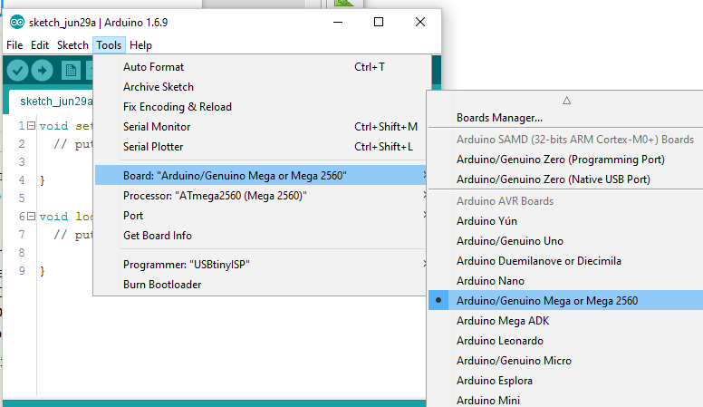Choosing the board to work with..

While the example above is from Windows, the MacOS Tool and Board options will be the same.
The next step is to select the port that the Mini-Rambo is using. In order to do that, you'll need to plug a USB cable into the Mini-Rambo, connect the power to the DropLit v2 and then turn it on.
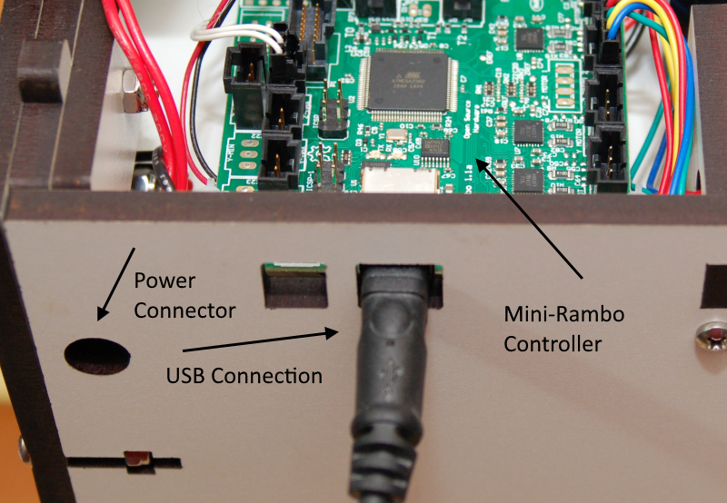Mini-Rambo, USB, and power connectors.

In the Arduino IDE, click on Tools and then Port. Select the port that the Mini-Rambo is connected to. Chances are pretty good that it's going to be listed as something other than COM1.
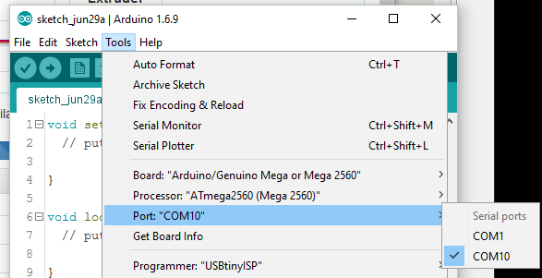Windows Port ID.
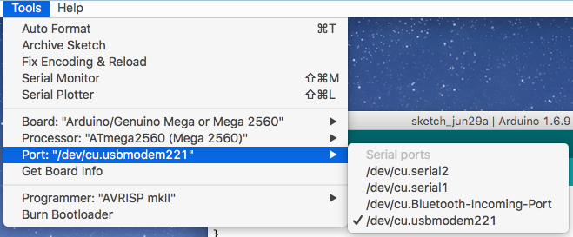MacOS Port ID.
As you can see, the port for the Macintosh is identified as “/dev/cu.usbmodem211”. It may not be exactly the same with your system, but it will be close.
Now that we've gotten the Arduino IDE ready to go, we'll need to run a small program to clear the EEPROM on the Mini-Rambo. To load that program into the Arduino IDE, click on File, Examples, EEPROM, and finally on eeprom_clear.
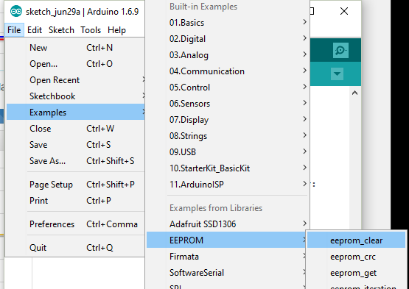Loading the EEPROM clearing program.

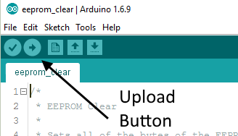
After the program is loaded, click on the Upload button as indicated below.
When you click the Upload button, the Arduino IDE will compile the eeprom_clear program and then upload the result to the Mini-Rambo board. The process should only take a few seconds. When it's finished, you'll see a result that looks similar to the one shown below.
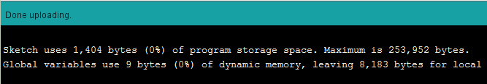

Now it's time to configure the DropLit v2 firmware and get it uploaded to the Mini-Rambo!
The file you want to load is called Repeiter.ino and will be found in the “Repetier” sub-directory where you unpacked the downloaded firmware.
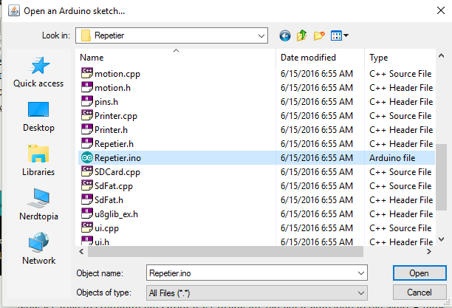Loading the firmware.

Before you can upload the firmware to the Mini-Rambo, you'll need to make two changes to a file called Configuration.h. Click on the Configuration.h tab in the Arduino IDE. If that tab isn't visible, click on the small down-arrow to open a list of the files currently loaded in the Arduino IDE. You can pick Configuration.h out of that list.
Now scroll down a little until you see the section that matches the image below.
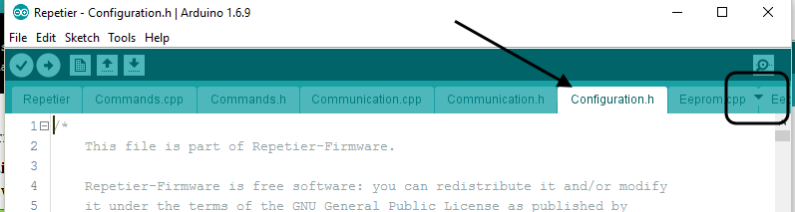Configuration.h tab.
You need to make sure that the MOTHERBOARD definition is set to “302” for the Mini-Rambo and PRINTER is set to “4” for the DropLit v2. Now click on Save to save your changes.
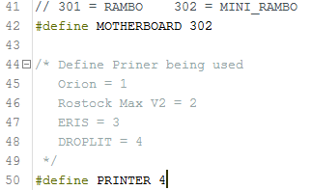Configuring the firmware.
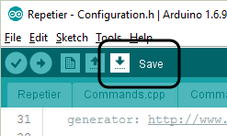

Once the changes have been saved, you can click on the Upload button. Once the upload has completed, you're ready to write nanoDLP SD card image out to your SD card!

3 – Installing nanoDLP
If you're using MacOS, you'll need to follow the guidelines outlined here:
https://www.raspberrypi.org/documentation/installation/installing-images/mac.md
You'll use those instructions to write out the nanoDLP SD card image.
For Windows users, you'll use the Win32DiskImager utility that you downloaded earlier. Note that in order for Win32DiskImager to work properly, you'll need to run it as Administrator. You can do that by right-clicking on the Win32DiskImager program as shown below. (Note that the default install name for Win32DiskImager is “Image Writer”, not “SD Card Image Writer” as shown on Windows 10 example.
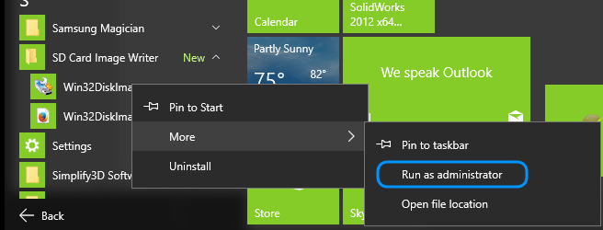Running in Windows 10.
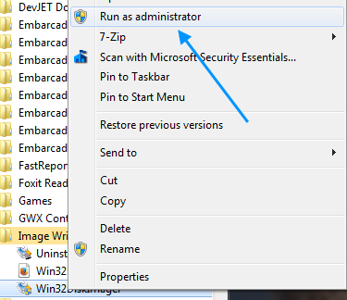Running in Windows 7.

When you click on Run as administrator, you'll be prompted with a dialog box asking your permission to continue. Click on “Yes” to continue.

After Win32DiskImager starts, click on the folder icon to open the nanoDLP SD card image. Next, select the drive letter of the SD card you're going to be writing the image to. Make sure you've selected the correct device! To help avoid accidently clobbering another device, it would be a good idea to remove any USB thumb drives or SD cards other than the one you're going to write to.
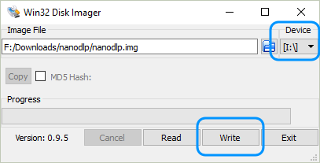
Click on the Write button to begin the writing process. The software will warn you to make sure you've chosen the correct device and will then begin the writing process once you allow it.

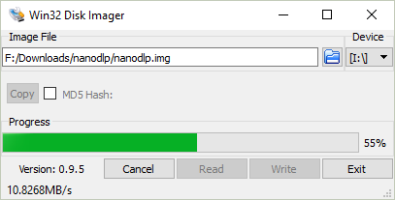
When the process completes, eject the SD card from your system and insert it into the Rasbperry Pi 3 as shown below. Please make sure you've turned off the power to the DropLit v2 before you do this!
Note that it may be easier to install the SD card if you remove it from the DropLit v2 first.
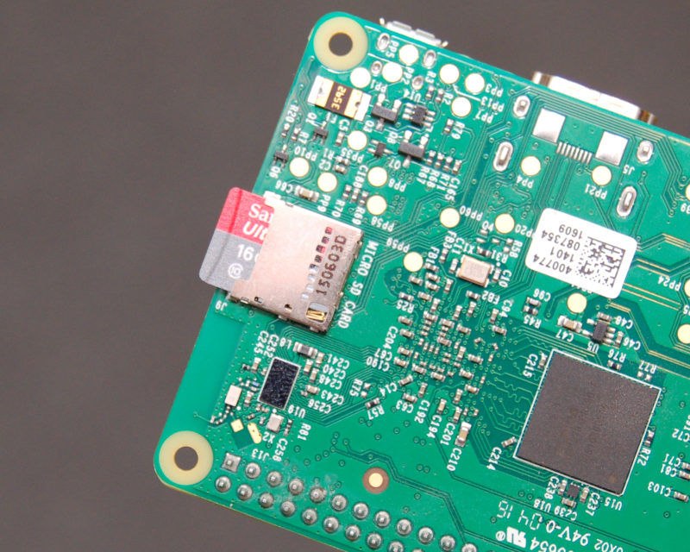SD card installed.
If you removed the Raspberry PI 3 to install the SD card, please re-install it now and we'll continue!
Replace the top to the DropLit v2 and connect the included USB cable from the Rasberry Pi 3 to the Mini-Rambo as shown.

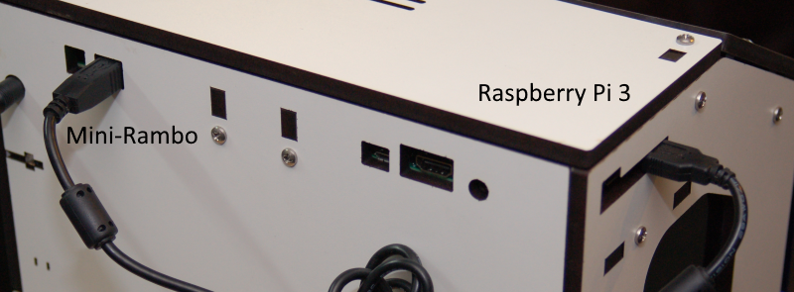Mini-Rambo connected to the Raspberry Pi 3.

4 – Configuring nanoDLP

4.1 – Connecting to the DropLit v2
In order to communicate with the DropLit v2 the first time, you'll need to connect an Ethernet cable from your Internet router to the Raspberry Pi 3.
Power up your DropLit v2 and after about a minute, you'll be ready to access the printer.
If you're running Windows, you can open up Exporer and click on the Network item (most often found in the left side of the Explorer window.)
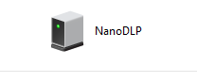
For MacOS users, you may be able to locate the DropLit v2 via the Network window in the Finder.
You're looking for an item that looks similar to the one shown on the right. It should be named NanoDLP. You can right-click on the icon to access it via your web browser.
If that icon doesn't appear, you can try the nanoDLP dashboard. This can be found at http://www.nanodlp.com/dashboard. If the nanoDLP dashboard can see the Raspberry Pi 3 in the DropLit v2, you'll see a page similar to the one shown below.
The first thing you'll want to do is check to see if there's an update available. If it's present, click the “New Version Available” button and follow the instructions it gives you.
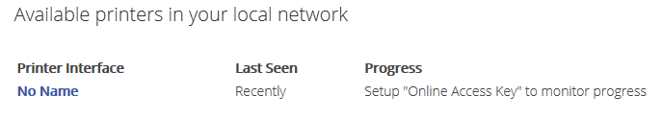The nanoDLP dashboard page.
The update should only take a few minutes and the Rasberry Pi 3 will be restarted when the update is finished. To check, refresh the web page after about 5 minutes.

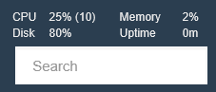
4.2 – Expanding the Filesystem
After any updates have completed, the next task will be to expand the filesystem on the SD card to consume the available space. The nanoDLP SD card image is designed to fit on a 2GB SD card. However, the unit shipped with the DropLit v2 is 8GB. Expanding the filesystem will allow you to use all of that space for storing print jobs.
As you can see from the image on the right, the “disk” is at 80% of it's capacity.

You can easily expand the filesystem straight from the nanoDLP web interface. Simply click on the Setup button and then click on the Tools tab.
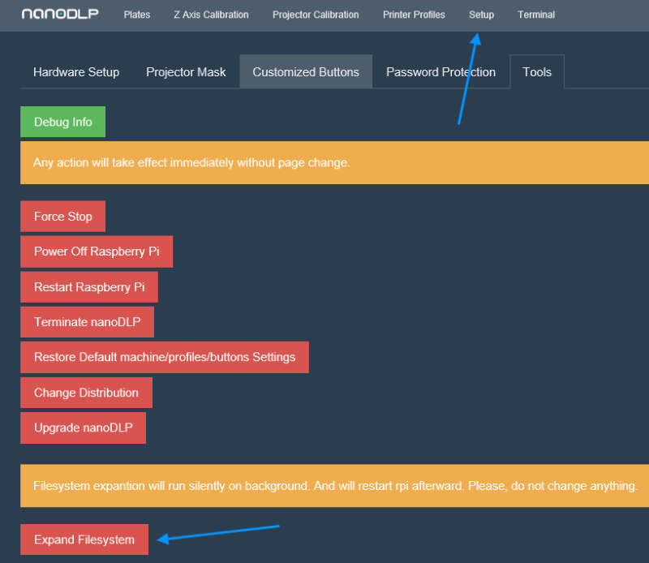Expanding the filesystem.

Click on the Expand Filesystem button to begin the process. The process is actually pretty fast – give it about a minute and refresh your browser window. The statistics display should now show a lot more space available on the disk.
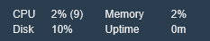So much room for activities!

4.3 – Hardware Setup
Now it's time to configure nanoDLP to control the DropLit v2. Click on the Setup button and then click on the Hardware Setup tab (if it doesn't take you there by default).

Printer Name is pretty obvious. Pick whatever name you like!
For the parameters shown in the image below, there's nothing you need to change.
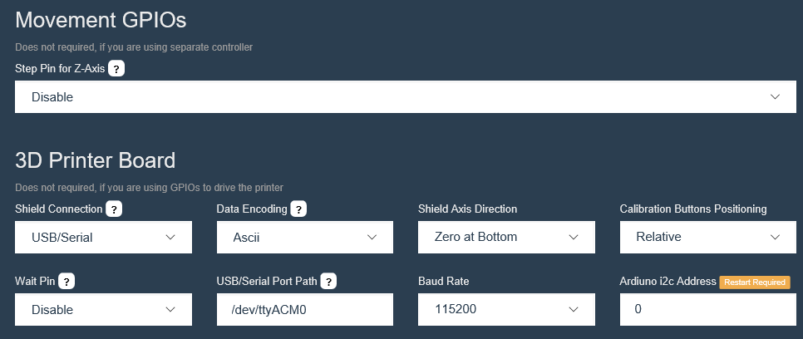
Note that if your configuration doesn't match what I show above, please change them to comply with what the image above shows.
The first parameter that needs updating is GCode – Bootup. Add the text below to that field.
G91
G1 Z.1 F100
G4 P100
Next is GCode – Start of Print.
G90 ; Put positioning in absolute mode
[[Delay 1.5]]
[[PositionSet 0]] ; Set current position on nanodlp so it could be recovered in case of failure
If you're copying/pasting, please make sure you're not including the tabs. The text should be aligned along the left edge of the input field.
Next is GCode – End of Print.
M84 ;Disable Motors
;<Completed>
Set the Shutter control to “Disabled”.
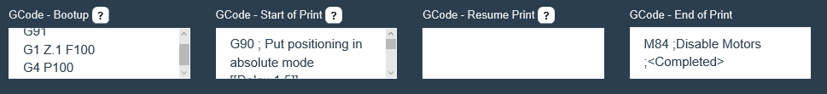Example showing correctly set fields.
Set the resolution of your projector using the Projector Resolution Width and Projector Resolution Height fields as shown below. The values shown are correct for a typical “1080p” projector.
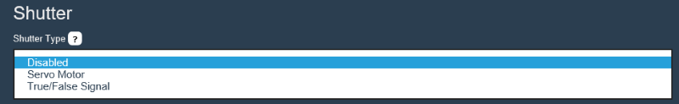Shutter disabled.
The Platform/Resin settings should be set as you see below.
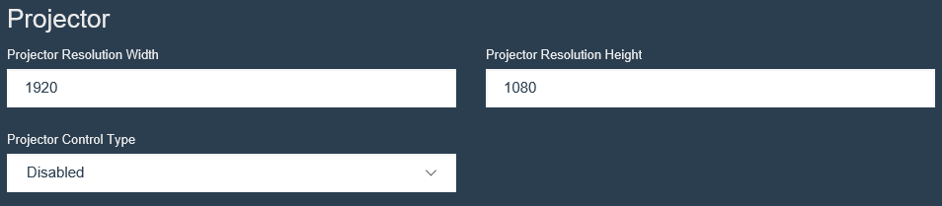Standard 1080p resolution settings.
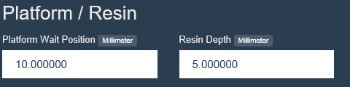Default Platform/Resin settings.

The Speed settings for the DropLit v2 differ quit a bit from the default nanoDLP settings, so make sure you get them changed. Below are the correct values for the DropLit v2.
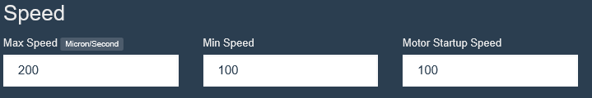New Speed settings.
The Actuator/Motor settings tell nanoDLP about the drive hardware & electronics used in the DropLit v2.
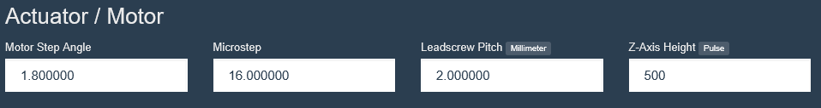 Settings for the Mini-Rambo & DropLit v2's stepper motor.
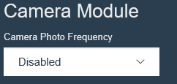
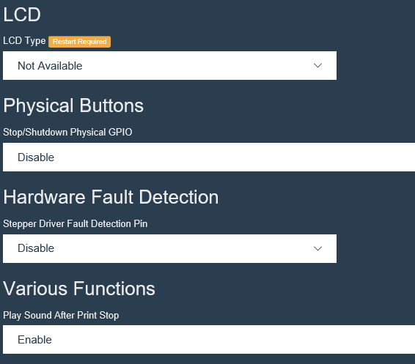
nanoDLP has support for using a camera to take photos periodically as the print progresses. This is a great tool to observe your print as well as the resin level in the vat. For now this feature is disabled – however if you obtain a camera that is compatible with the Raspberry Pi 3, this is how you can enable it for use with nanoDLP.
The remaining parameters are shown on the right. The defaults that ship with nanoDLP should be ok, but check to make sure they're set the same way.
Click on the Submit button on the bottom of the page to save your changes and we'll move on to the next tab!

The default Projector Mask setting can be left as it is, so I won't cover it here.

4.4 – Customized Buttons
Click on the Customized Buttons tab. We've got a single button to add!
NanoDLP supports adding buttons to the user interface in order to perform special tasks. In this instance, we need to add a “Disable Stepper” button to the Z-Axis Calibration page. The figure below shows all the settings for the new button. The only data you'll need to type in is the button name, the Gcode, and the confirmation text. The other options are drop down selections.
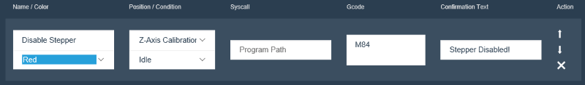
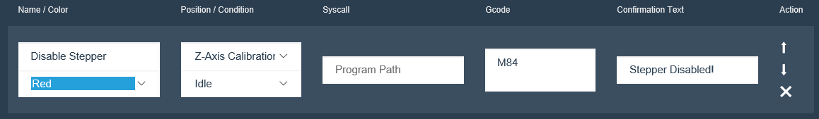
When you're done, click the Submit button. You can see the new button in place if you click on the Z Axis Calibration link.
Below you'll see what the new button looks like!
Z Axis Calibration link.
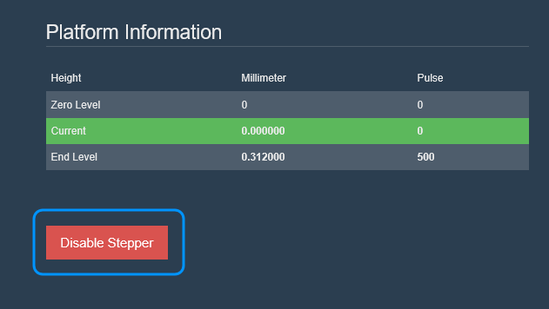Newly added button.

4.5 – Creating a Printer Profile
Printer Profiles in nanoDLP allow you to set a wide number of parameters to control resin cure times and layer thicknesses. Click on the Printer Profiles link and we'll get started!

The profile Title is pretty self-explanatory. I recommend that you use a similar format to what I show on the right – the name of the material and its color.
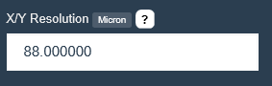
The X/Y Resolution parameter is one you'll need to calculate.

Appendix A – Manually Expanding the Filesystem
In order to manually expand the filesystem on the Raspberry Pi 3, we'll need to connect to it via ssh. If you've used a ssh terminal before, you can just skim down to the login instructions.
For Windows users, I'll cover using PuTTY and for MacOS users, I'll cover using the ssh program from a terminal window.
First up, you'll need to know the IP address of your DropLit v2. You can find the IP address by looking at the address bar in your browser.
Windows
Start up PuTTY and enter the IP address of your DropLit v2 into the Host Name box. You'll want to make sure that “SSH” is ticked. Enter the name of your printer in the Saved Sessions box and then click the Save button.
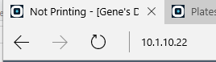Address example.
Click the Open button and it will open a terminal window and connect to the DropLit v2. Note that you may be prompted to accept a security certificate when you first connect – that's expected and it's okay to allow it. Enter “pi” as the login name and “raspberry” as the password. You can change this later if you like.
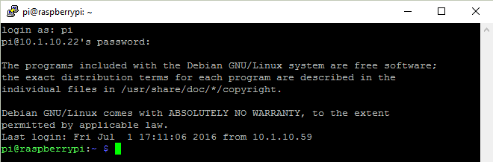Connecting with PuTTY.

Macintosh
Open up a terminal window and enter in “ssh -l pi <ip address>” (without the quotes). Ex. “ssh -l pi 10.1.10.22”. The “-l” you see is a lower case letter “L”. This is required because without it, the ssh client will attempt to connect using your username. Since you don't have an account on the Raspberry Pi 3, you won't be able to log in.
Since this is the first time connecting, you'll be prompted to authorize the connection. Enter “yes” at the prompt. The default password for the “pi” account is “raspberry”. You can change this later if you like.
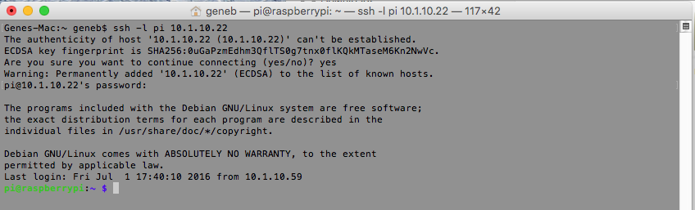Connecting with MacOS.
Now that you're connected, let's get that filesystem expanded, shall we?
Change to the printer directory by entering “cd printer” <enter> and then type in “ls” <enter> to bring up a directory of the files in the printer directory.
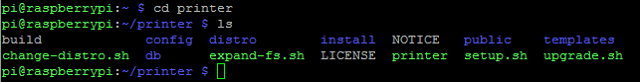
The thing we're after is called “expand-fs.sh”. This is a shell script that will start the process of expanding the filesystem on the SD card.

Before we run that command, enter in “df -h”. This will show you the current amount of free space there is on the SD card, before we expand it.
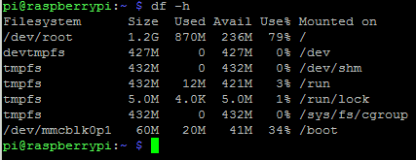
The figure we're after is the “/dev/root” line. It shows we've only got 236MB of space free!

Go ahead and execute the expand-fs.sh script by entering “sudo ./expand-fs.sh” and press Enter. The program will quickly do it's task and then reboot the Rasbperry Pi 3. This will reset your connection of course, so you'll need to reconnect.
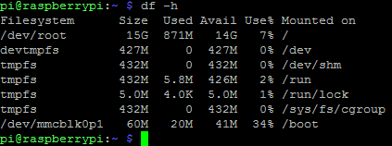
Check the free space as you did before – this time you can see that the root filesystem now has 14GB available. So much room for activities!

